Building a Scalable eCommerce Platform with Microservices, Kafka, and Kubernetes

Abstract:
This article presents a real-world implementation of a full-stack, microservices-based eCommerce platform built entirely using open-source technologies. Key business domains—Product Catalog, Orders, Wishlist, Chat, and Notifications—are modularized into independently deployable services communicating through a hybrid model of REST APIs and Apache Kafka. The system is deployed using Docker and Kubernetes (via Minikube) to simulate production-level orchestration and auto-scaling. MongoDB and PostgreSQL are used selectively based on data characteristics. The frontend, developed using Next.js, integrates WebSocket-based real-time messaging, Kafka for asynchronous communication, and Clerk.dev authentication. This project demonstrates how open-source tools can power scalable, reactive applications with production-grade architecture and provides insights into containerized deployments, observability, and service communication patterns.

1. Introduction:
In the modern digital ecosystem, building scalable and maintainable applications demands more than just writing code—it requires smart architecture, efficient communication between services, and seamless deployment pipelines. Microservices architecture has emerged as the go-to solution for developing complex, modular systems that can evolve rapidly without breaking the whole application.
This article dives into the development of a full-stack eCommerce platform built using open-source technologies. From backend services written in Node.js and Express, to Kafka-powered asynchronous communication, to a containerized deployment on Kubernetes using Minikube—every layer is designed to reflect a real-world, production-grade microservices environment.
The frontend, built using Next.js, is tightly integrated with Clerk.dev for authentication and interacts with backend services through REST APIs and WebSockets for real-time responsiveness. This project serves as a hands-on blueprint for developers looking to build distributed, event-driven systems using open source tools—offering practical insights into architecture, deployment, and scalability.

2. System Architecture:
The architecture of the platform is based on a modular microservices approach, where each functional unit is isolated into an independent service. This design promotes scalability, ease of maintenance, and rapid deployment.
Each microservice—Product, Order, Wishlist, Chat, and Notification—is responsible for a single domain and communicates with other services through a hybrid model:
- Synchronous communication using REST APIs for immediate, request-response interactions (e.g., Wishlist fetching product details).
- Asynchronous communication using Apache Kafka, allowing services to publish and consume events decoupled from one another (e.g., Order Service publishing to a notification topic).
All backend services are Dockerized and orchestrated via Kubernetes (Minikube), enabling features such as: independent deployment of services, service discovery and internal routing via ClusterIP, autoscaling using Horizontal Pod Autoscaler (HPA) and environment-specific configuration through ConfigMaps and Secrets.
The platform uses a polyglot persistence strategy: MongoDB for semi-structured or dynamic data (Products, Chat, Wishlist) and PostgreSQL for transactional integrity (Orders).
The frontend, built using Next.js, interacts with backend services over REST APIs and WebSocket connections, enabling real-time experiences such as live chat. Clerk.dev handles user authentication and access control using secure token-based sessions.
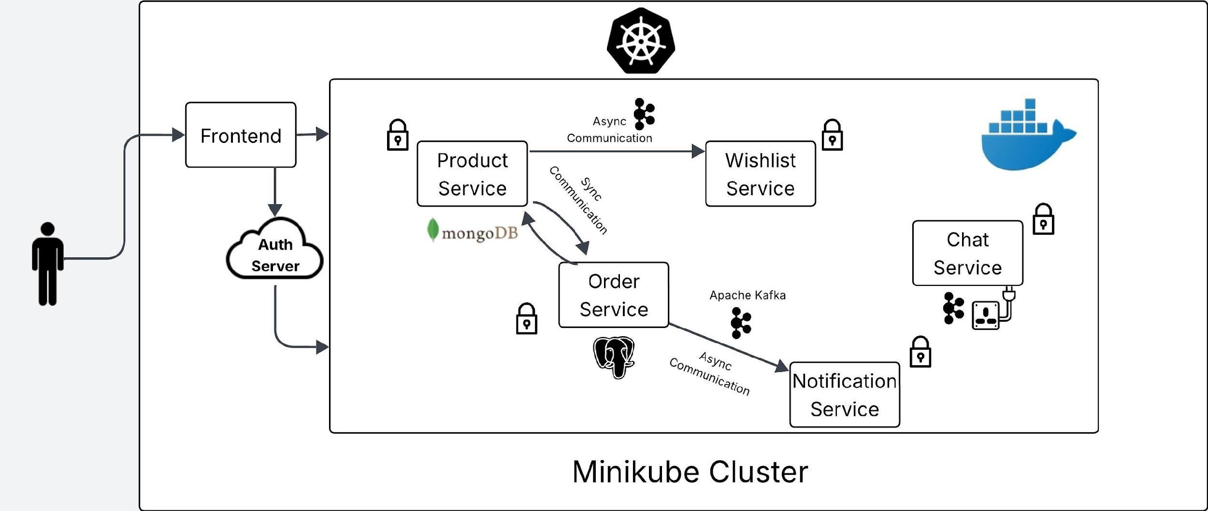
Figure 1: System architecture of the eCommerce platform
This architecture simulates real-world, production-level deployments and demonstrates how open-source technologies can power fully scalable and reactive applications.

3. Technology Stack
This eCommerce platform is built using a suite of modern, open-source technologies—each selected for its robustness, flexibility, and community support. The stack spans backend APIs, asynchronous messaging, containerization, orchestration, and frontend development.
- Backend
- Node.js: A non-blocking, event-driven runtime perfect for handling high I/O workloads.
- Express.js: A minimalist framework used to define RESTful API routes across services.
- Kafka (Apache Kafka): Powers asynchronous, event-driven communication between services using topics like product-events, order-events, and chat-events.
- kafkajs: Lightweight Kafka client for Node.js, used to implement producers and consumers.
- Databases
- MongoDB: Used in Product, Wishlist, and Chat services for handling semi-structured data with schema flexibility.
- PostgreSQL: Used in the Order Service where transactional integrity and relational data modeling are essential.
- Prisma ORM: Used with PostgreSQL for schema validation and type-safe database operations.
- Frontend
- Next.js: React-based framework enabling server-side rendering, static site generation, and dynamic routing.
- WebSocket: Used for real-time features such as chat and notifications.
- Axios/Fetch API: For interacting with backend REST endpoints.
- Clerk.dev: Provides secure user authentication, role-based access control, and JWT-based session handling.
- Infrastructure & Deployment
- Docker: Each microservice is containerized to ensure consistent environments across development and deployment.
- Kubernetes (Minikube): Orchestrates all services, managing pods, scaling, and service discovery.
- Horizontal Pod Autoscaler (HPA): Automatically adjusts service replicas based on CPU utilization.
This tech stack creates a solid foundation for building distributed, scalable applications while keeping development efficient and modular. Each tool plays a crucial role in transforming this project into a near-production-grade system.

4. Microservices Overview & Communication Flow
The platform’s backend is divided into five core microservices, each encapsulating a specific domain and operating independently. This modularity ensures better scalability, team ownership, and fault isolation.
- Core Microservices
- Product Service: Handles product listings, categories, and seller-specific data. Database: MongoDB
- Order Service: Manages order placement, payment status, and tracking. Database: PostgreSQL
- Wishlist Service: Allows users to save and manage products of interest. Database: MongoDB
- Chat Service: Enables real-time buyer–seller communication. Tech: WebSocket + MongoDB + Kafka
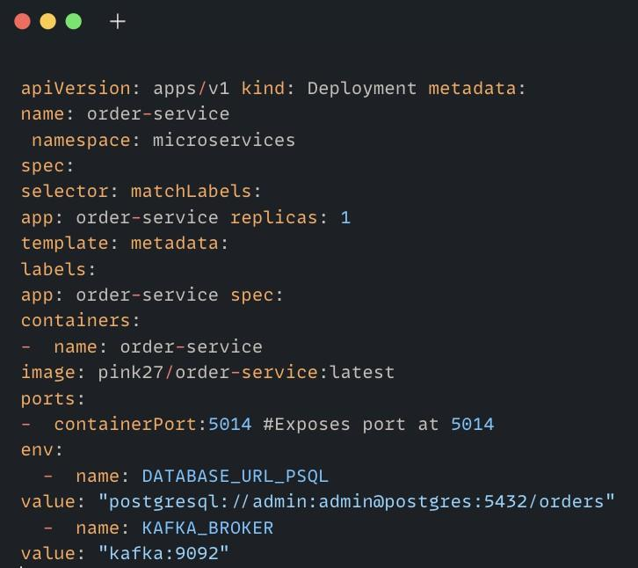
- Notification Service: Sends system-generated alerts triggered by Kafka events.
Tech: Kafka + WebSocket (for frontend push)

Figure 2: Microservices and their associated databases and responsibilities

- Inter-Service Communication
A hybrid communication model is implemented for optimal responsiveness and scalability:
- Synchronous (REST APIs): Used for direct data access and CRUD operations.
Example: Wishlist calls Product Service to fetch product details.
- Asynchronous (Apache Kafka): Enables decoupled, real-time workflows.
Example: When an order is placed, an order-event is published to Kafka. Notification and Chat services consume this event.
Each service subscribes only to the topics relevant to its business logic (e.g., order-events, chat-events, notification-events), ensuring clean separation and scalability.
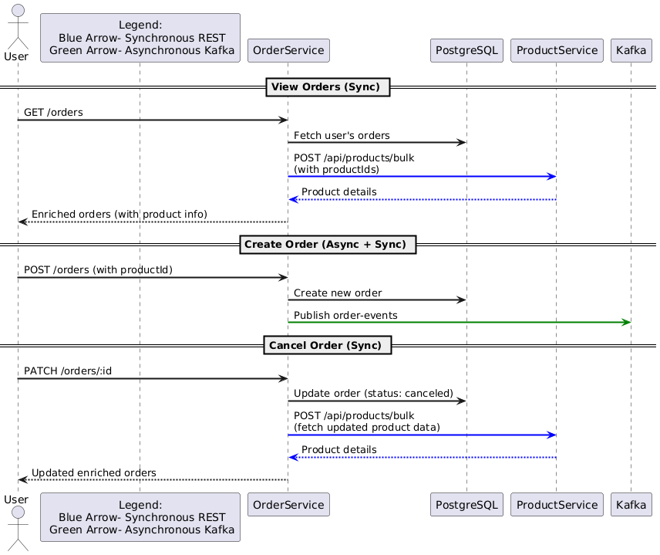
Figure 3: REST and Kafka-based communication between services

This setup not only enhances performance under load but also simplifies debugging and horizontal scaling. REST handles immediate tasks, while Kafka ensures reactive behavior and eventual consistency.

5. Deployment Architecture
The entire application is containerized using Docker and orchestrated on a local Kubernetes cluster via Minikube. This setup closely mirrors production environments, offering service resilience, scalability, and ease of management.
Each microservice runs in its own Docker container, exposing only the necessary ports and packaged with minimal dependencies. These containers are managed via Kubernetes Deployments, which ensure desired pod states and handle restart policies, scaling, and updates.
a) Key Kubernetes Components
- Pods & Deployments: Each service has its own deployment definition and can be scaled independently. Example: The Product Service runs with 2–4 replicas based on CPU load.
- ClusterIP Services: Internal DNS-based service discovery, allowing one microservice to reach another by name. e.g., http://order-service:5020/api/orders.
- ConfigMaps & Secrets: Used to inject environment-specific variables like DB URIs, Clerk keys, Kafka broker addresses, etc., into each container securely.
- Horizontal Pod Autoscaler (HPA): Automatically adjusts the number of running pods based on resource usage metrics. For example, Product Service scales based on CPU utilization under high traffic.
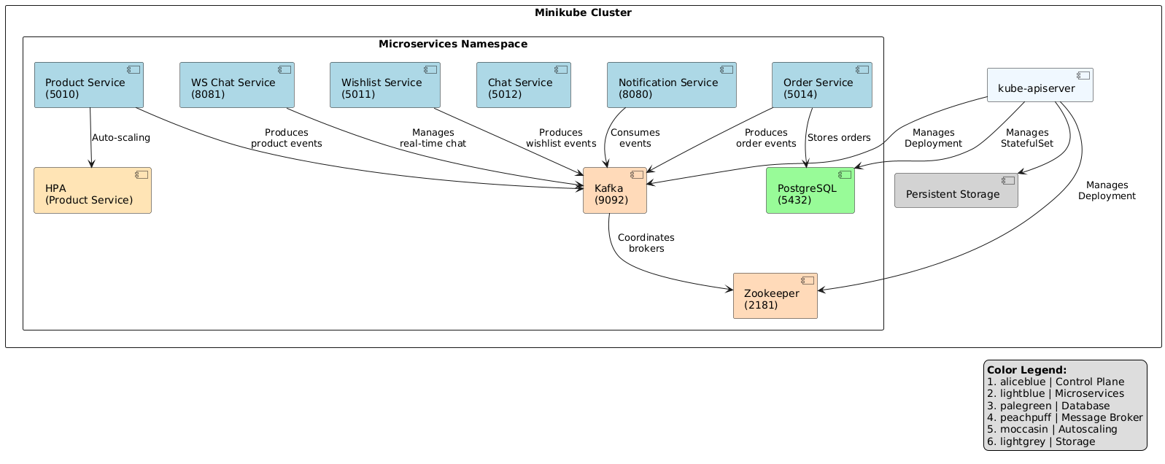
Figure 4: Kubernetes Deployment Diagram
b) Benefits of This Deployment Setup
- Simulates real-world DevOps pipelines using open-source tools.
- Supports modular redeployment - no need to restart the whole system.
- Simplifies scaling and fault recovery.
- Maintains clear separation between development, configuration, and runtime.
This architecture allows developers to iterate quickly, roll out features safely, and experiment with real-time load balancing and observability tools like Prometheus and Grafana.

6. Frontend Integration & Authentication
The frontend of the platform is built using Next.js, a powerful React framework that supports both server-side rendering (SSR) and static site generation (SSG). It provides fast page loads, improved SEO, and dynamic routing—key for building interactive eCommerce experiences.
Users can browse products, manage wishlists, place orders, and chat with sellers, all through an intuitive and responsive interface.
a) Frontend Features
- Next.js Routing: Dynamic pages for products, cart, orders, chats, and login.
- API Integration: Uses axios and native fetch() to call backend REST APIs hosted on each microservice.
- WebSocket Connections: Enables real-time chat and live notifications from the backend via persistent sockets.
- Session Management: Local storage and Clerk’s SDK manage secure token handling across sessions.
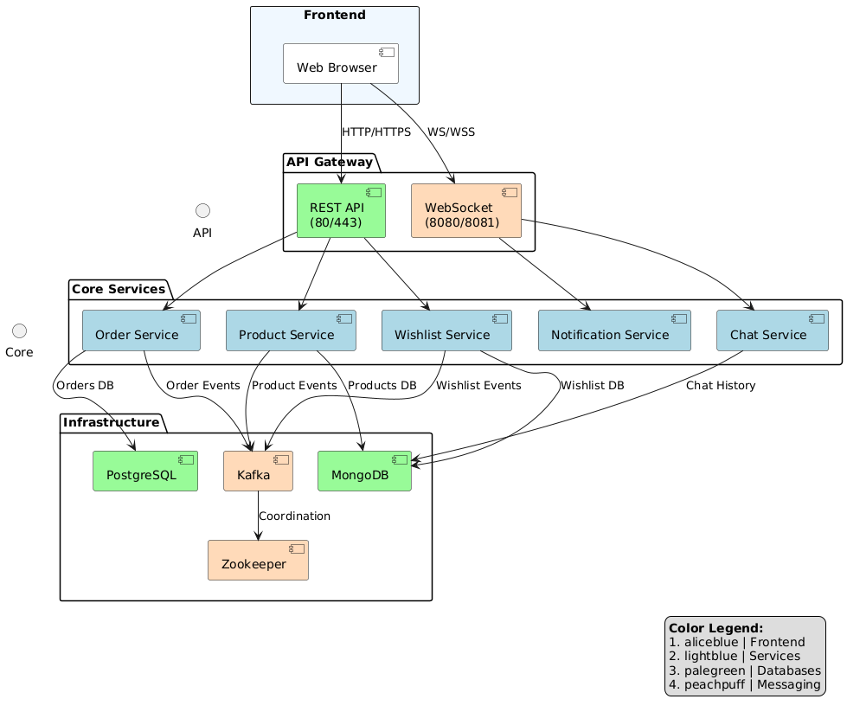
Figure 5: Frontend Interaction with Backend via REST & WebSockets
b) Authentication with Clerk.dev
Authentication and authorization are handled using Clerk.dev, a plug-and-play identity platform offering: Prebuilt sign-up/sign-in UIs, Secure JWT-based session management, Role-based access control (e.g., buyer, seller) and Integration with the frontend through Clerk’s React SDK.
Once users log in, Clerk provides JWTs that are attached to every frontend API request. Backend services validate these tokens to ensure only authenticated users can access protected routes.
This offloads complex auth logic from your codebase while keeping identity management secure and scalable.

7. Experimental Challenges & Learnings
Building this microservices-based eCommerce platform was not without its hurdles. From inter-service communication bugs to deployment quirks in Kubernetes, every step offered valuable hands-on experience. Below are some of the key challenges faced and what we learned from resolving them.
- Kafka Setup & Debugging
- Challenge: Setting up Kafka on Minikube and ensuring services could consistently produce/consume events.
- Learning: Network policies in Kubernetes can block inter-pod communication if not configured properly. Exposing Kafka with correct listeners and using kafkajs with proper retry logic helped stabilize message flow.
- WebSocket Handling
- Challenge: Maintaining persistent WebSocket connections across multiple services and pods.
- Learning: Centralizing WebSocket logic in dedicated services (Chat, Notification) and using topics to forward events from Kafka to frontend greatly simplified architecture and improved stability.
- Autoscaling with HPA
- Challenge: CPU thresholds were too sensitive, leading to unnecessary scaling.
- Learning: Fine-tuning targetCPUUtilizationPercentage and using custom metrics can make autoscaling more predictable.
- Auth Token Propagation
- Challenge: Passing JWT tokens across services and ensuring backend verification.
- Learning: Each service validates tokens individually via middleware; Clerk’s SDK made token decoding easier, but caching Clerk’s public keys reduced verification latency.
- MongoDB vs PostgreSQL Use
- Challenge: Choosing when to use NoSQL or relational databases.
- Learning: Use MongoDB for flexible and fast reads (e.g., product listings), and PostgreSQL when data consistency and transactions are critical (e.g., orders, payments).
Overall, these challenges transformed theoretical understanding into real DevOps and backend engineering skills—highlighting the power (and complexity) of distributed systems in real-world scenarios.
8. Conclusion & Future Scope
This project was a comprehensive exercise in building a real-world, production-style application using a microservices architecture powered entirely by open-source technologies. By combining tools like Node.js, Kafka, Docker, Kubernetes, MongoDB, and Next.js, we were able to create a scalable, modular, and reactive eCommerce platform that mirrors modern cloud-native applications.
Beyond technical implementation, the project provided deep insights into the challenges of distributed system design—inter-service communication, data consistency, authentication, and observability.
Future Enhancements
- Ingress Controller: To enable external access and URL routing with TLS support.
- CI/CD Pipeline: Automating deployment with tools like GitHub Actions or Jenkins.
- Observability Tools: Integrate Prometheus and Grafana for real-time system monitoring.
- Advanced Caching: Use Redis to optimize product listings and reduce DB load.
- Cloud Deployment: Port the Minikube setup to a managed Kubernetes service like GKE or EKS.
With modular design, open-source tooling, and hands-on implementation, this project not only served as a strong learning experience but also demonstrated the feasibility of building robust systems without relying on closed-source or proprietary platforms.

About the Authors: Vihan Vashishth, Vineet Priyedarshi and B. Thangaraju. The authors are associated with the Open Source Technology Lab at the International Institute of Information Technology, Bengaluru.

